

**How to use Microsoft Excel**

A User Based Documentation Guide

Created by:

Katie Hibner for Code for Nepal



Attribution-NonCommercial-ShareAlike CC BY-NC-SA

**Introduction**



This document provides step-by-step instructions for creating a table in Microsoft Excel. It also provides instruction on how to create a column that performs an average calculation of selected cells, but this is an optional step that may be useful. Because this documentation focuses on gathering and preserving data and making meaning from that data, I am focused on addressing the Curation component of digital literacy.

This document is helpful to beginners looking to learn Excel because it provides the process of creating a table in Excel, which is the foundation of Excel uses. My document will be especially useful to teachers because learning how to track data in Excel can be very helpful. Tables help users organize data in a way that is easy to understand. Teachers can use Steps 1 and 2 to create tables that track attendance, assignments, and/ or student behaviors. Step 3 adds a column that calculate averages, the typical value of a group of numbers. This Step will be helpful for teachers who want to calculate a student's overall grade by averaging their assignment grades.

In order to use Microsoft Excel, you will need to have the Microsoft Excel program downloaded on your computer. If you do not have this, Google provides a free, online version of Excel called Google Sheets. You can find more information about Google Sheets by going to the internet and searching "www.benlcollins.com/spreadsheets/how-to-use-google-sheets/"

In order to use Microsoft Excel, you will also need to have a data set you want to organize. This could be students' attendance, grades, assignment progress, behavioral habits, and more. For this document, I will focus on tracking student grades, using made-up students and grades for made-up assignments. But you can use this document to track other types of data; just change the headers to label the data you are using. I am tracking assignment grades, so I am making the headers the name of the assignments. If you are tracking attendance, you might want to put the dates as the headers.

I will provide the students' names and the grades they earned on the first 2 assignments. There are two assignments that I don't have grades for yet, but you can enter in information at any point in time. Here is the data set I will be using for my example:

Amir: 90, 80

Amita: 75, 80

Hamesh: 90, 95

Krishna: 82, 92

Sai: 88, 94

Tanak: 76, 96

**Definitions**



When using Excel, there are terms that you should know before you begin. Here is a list of words that will be used in this document.

**Mouse:** The arrow that you use to select things on thescreen.

**Cell:** A single box, or square, that you see making the gridpattern in Excel

**Row:** A line of cells that go side to side (horizontal).

**Column:** A line of cells that go up and down (vertical).

**Header:** The top row of the table that names the columns.

**Width:** The measurement from side to side

**Data:** The information that is collected and put into thetable. See the data set provided in Introduction for an example.

**Borders button:** This button allows you to outline your cellsin black. It gives you multiple options for borders. Picture:

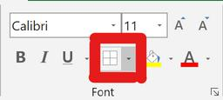

**Average Formula:** This has the ability to automaticallycalculate the average, or mean, of the selected values.

**List of Figures**



***Figure 1*:**Microsoft Excel logo, use this image to enter Excelfrom your desktop

***Figure 2*:**Windows logo; use this image to search forMicrosoft Excel if Figure 1 is missing ***Figure 3*:**Blank Excel Spreadsheet

***Figure 4:*** Spreadsheet with its headers filled in the top row

***Figure 5:*** Spreadsheet with its first column filled in withnames

***Figure 6:*** Spreadsheet that shows selected cells with the"Borders" button outlined in red

***Figure 7:*** Spreadsheet showing the second column, labelledB, selected and it's width extended

***Figure 8:*** Spreadsheet with the known data entered in thetable.

***Figure 9a:*** New column is named "Total Grade" in the table.

***Figure 9b:*** The formula, "=Average(" is typed in

***Figure 9c*:**The whole row is being selected for the Averageformula

***Figure 9d:*** The average for the first row is calculated andthat cell is selected, showing a green outline.

***Figure 9e***: Using the green square, the Average formula isdragged down to cover the entire column

***Figure 10:*** Spreadsheet showing the finished table is shown

***Figure 11:*** The "Save" button in Excel

***Step 1: Open Excel***



You have two options to open Excel:

If you see this image (Figure 1) on your desktop screen, you can quickly click it twice to open Excel.



If you don't see this image when you turn on your laptop, search for Excel by pressing the Windows button (Figure 2) on the bottom left corner of your screen.



Then type "Excel" and click "Open" when it comes up.



Your Excel will look like this:

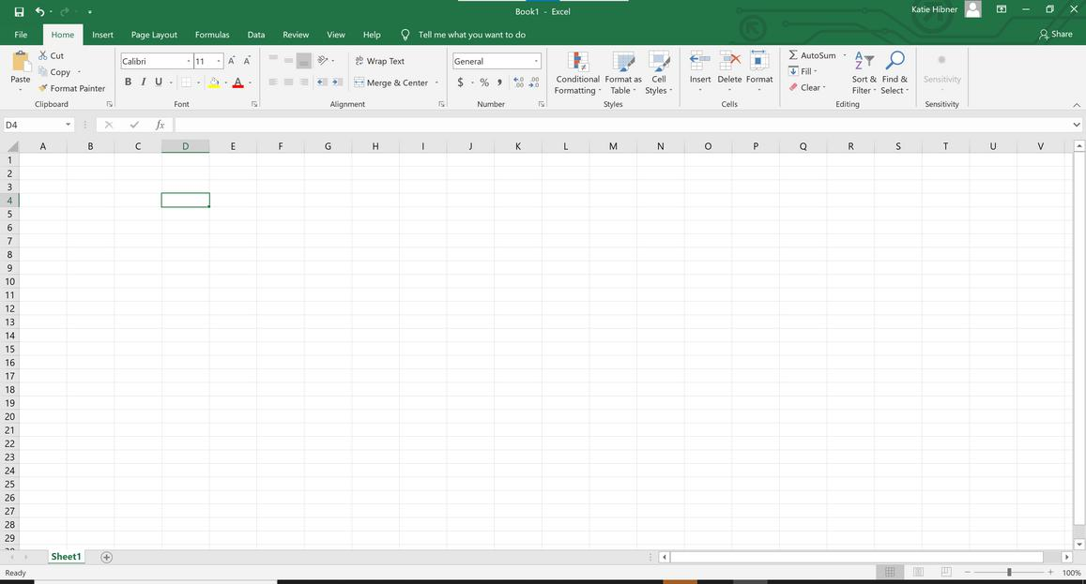

Figure 3: Blank Excel Spreadsheet

***Step 2: Create A Table***



Figure 1



Figure 2

***2.1- Fill in the first row with your headers***

1. Click inside the second cell of the top row.
2. Type in your first column's title.
3. Press "Tab" on your keyboard to go to the next cell.
4. Type in your second column's name, then press "Tab."
5. Continue until you fill in your column names.

Below, Figure 4 shows you what your Excel should look like with the headers from the example.

***2.1- Filled in Headers***

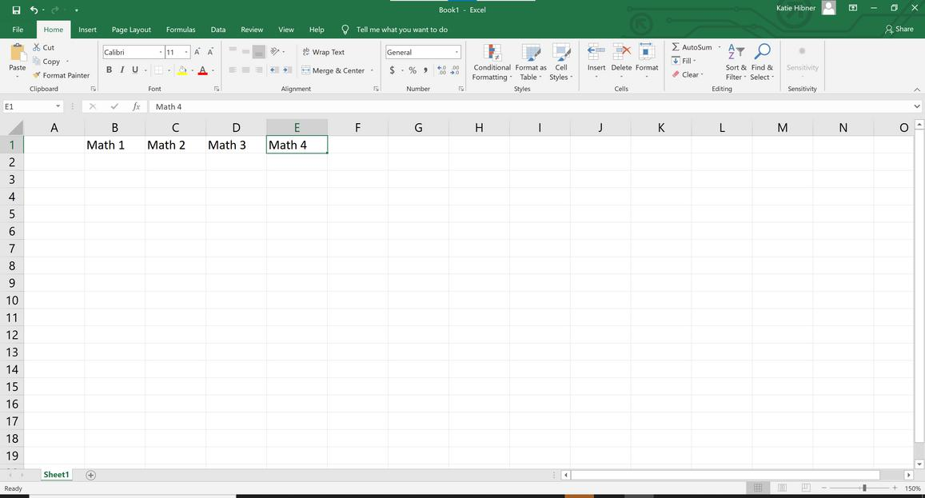

Figure 4: Headers are filled in the top row.

***2.2- Fill in the first column with student names***

1. Click inside the second cell of the first column. It is cell A2.
2. Type in your first student's name. In this example, this is "Amir."
3. When you finish typing the name, press "Enter" on your keyboard.
4. Type in your second student's name, then press "Enter."
5. Continue until you fill in all your students' names.

Below, Figure 5 shows you what your Excel should look like with the names from the example.

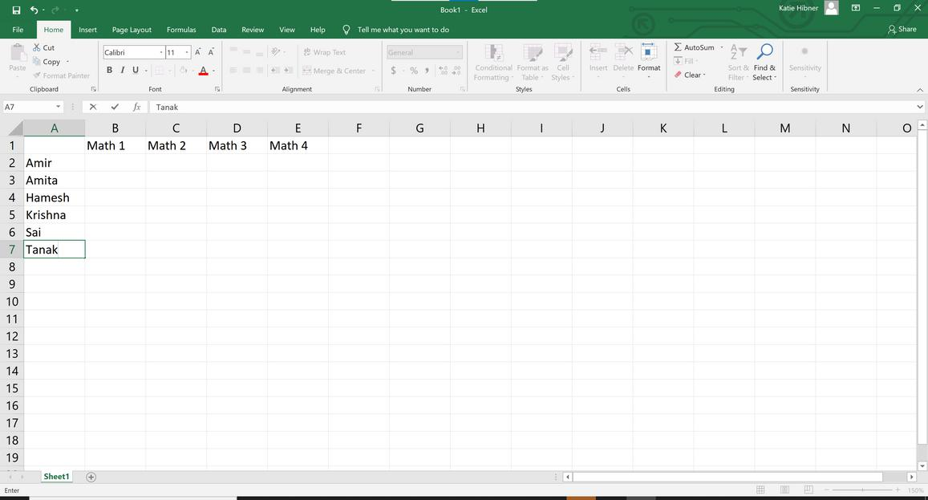

Figure 5: Table rows are labelled with student names

***2.3- Optional Edits***

*Add Borders*

1. Select all cells by clicking and holding in the first cell. That is A1.
2. Then, drag your mouse down and to the right until all of the cells are darkened.
3. You've selected the area you want borders in, which is going to be your table.
4. Click the arrow by the borders button, which is outlined in red in Figure 6. A more close-up picture is also provided under Definitions on page 3.
5. Once you click the area, click "All Borders" from the list.

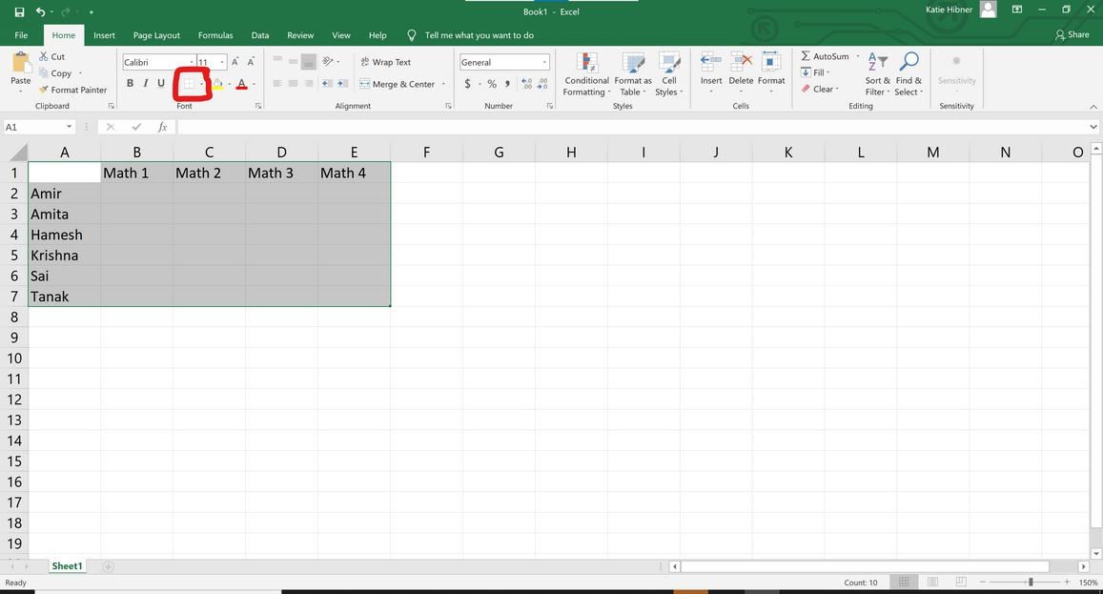

Figure 6: Shows selected cells with the "Borders" button outlined in red.

*Extend column width*

1. Click the letter that labels the column you want to widen. In Figure 7, B was selected.
2. Move your mouse to the side of the column until it turns into a cross, pictured to the right and in Figure 7.
3. Then click and drag to the side until it reaches the width you want.

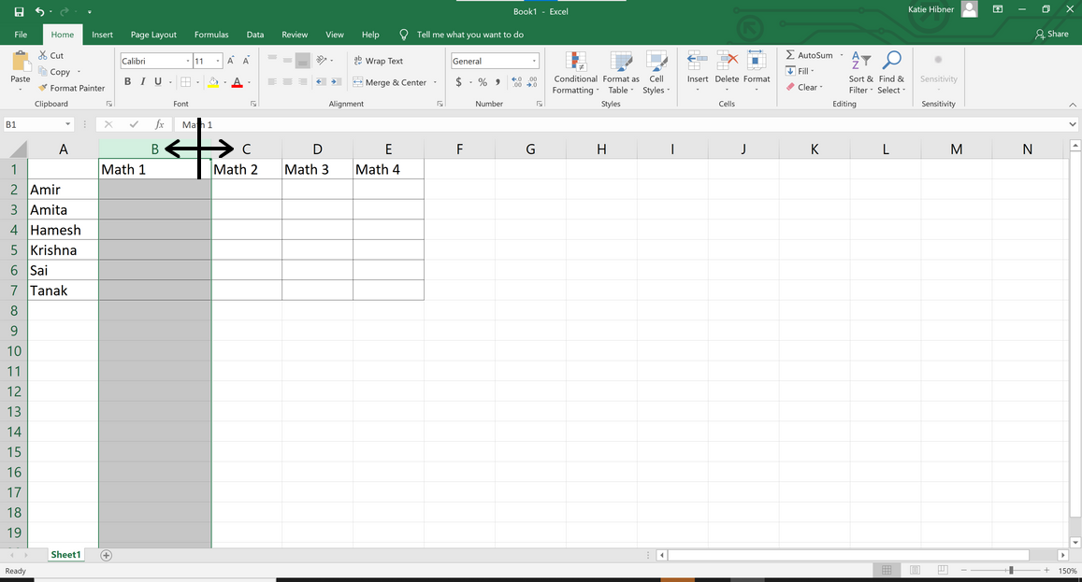

Figure 7: The second column, labelled B, is selected and it's width is extended.

***2.4- Fill in the data***

For each student, type in the known information, which is the grades on each assignment for this example.

1. Click in the top empty cell of the Math 1 column. This is Amir's row.
2. Type in Amir's grade for Math 1. He earned a 90 out of 100.
3. Press "Enter" to go down to the next cell.
4. Type in Amita's grade for Math 1. She earned a 75 out of 100.
5. Continue until all student's grades are put in for Math 1.
6. Then, click in the top cell of Math 2. This is Amir's row.
7. Type in the known grades for each student's assignment.
8. Leave the cell blank for any assignments that haven't been grade yet.

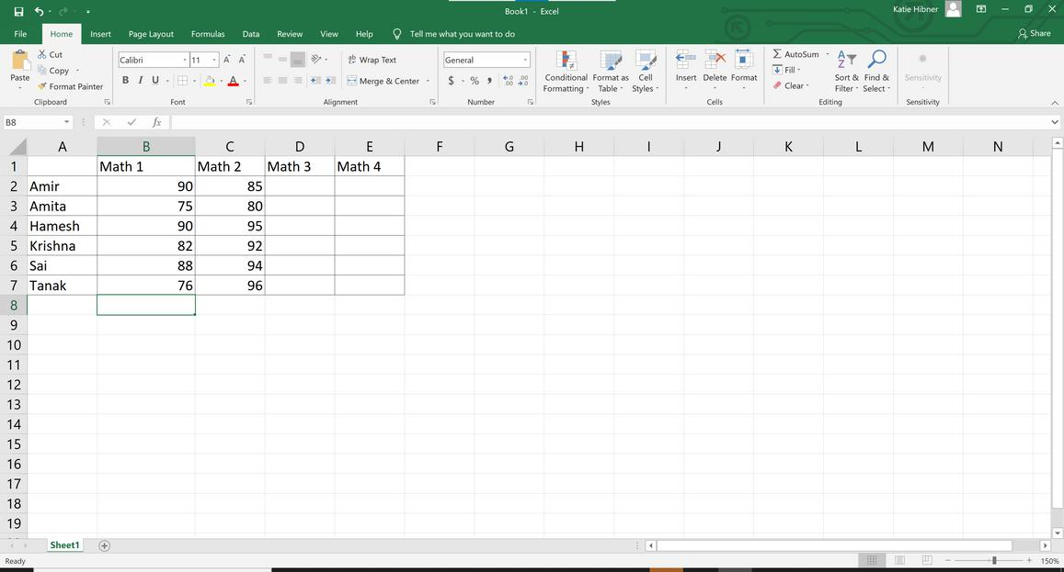

Figure 8: The known data is entered in the table.

***Step 3: Add function to the table***



Figure 8 shows a completed table. You can stop there. But Excel has helpful tools that can do work for you. In this example, we are going to add a column that will automatically perform math calculations. The following figures (9a, 9b, 9c, 9d, and 9e) are zoomed in pictures of the added elements to Figure 8.

***3.1- Add an 'Average' Column***

* 1. In the cell to the right of your last assignment, title your column. Suggestion: "Total Grade"

1. Click the cell below. Type "=AVERAGE("
   1. To select the range you want to average, click and drag from the first to the last assignment cell in the same row.

Figure 9a

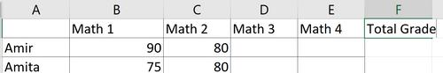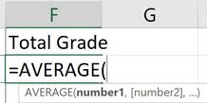

Figure 9b

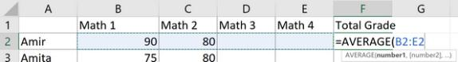

Figure 9c

* 1. Press "Enter" on the keyboard. This will calculate the average of that row. Click on the cell that just calculated the average. Notice the little square at the bottom right corner.

1. Click and drag the little square until the whole column is selected. Let go. The averages of each row will appear.

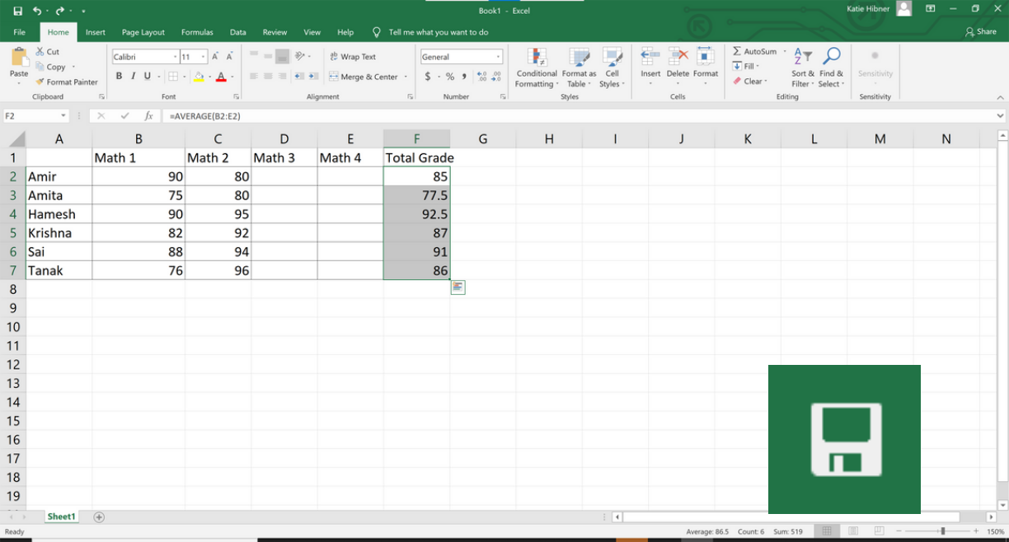

Figure 9d

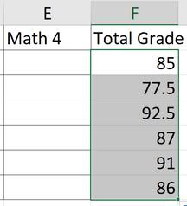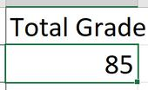

Figure 9e

Figure 10: This is what the table should look like when steps 1 through 5 are completed.

Now, the Total Grade column will automatically calculate an average for the values in the row. As you add in more data, the average column will calculate new averages. This saves you from having to do math yourself.

***Step 4: Save your work***



To save your work, press "File" in the top left.



Press "Save As" and select where you want to save your spreadsheet. This will be where you can find your spreadsheet when you want to come back to it.



After you save for the first time, you can save any new changes by clicking on the "Save" button in the top left corner (Figure 11).



Figure 11

